**WORKFORCE ADMINISTRATION SOLUTIONS**

Prepared for: Salesforce Developer Implementation

Project: Workforce Administration Solution (Dev)

Team ID: LTVIP2025TMID29847

**TEAM MEMBERS**

1.Vallamreddy.V.S.B.Padmavati

2. Malisetti Sai Lakshmi Deepika

3. Naga Lakshmi Surapureddy

4. Santha Kumari

**Table Of Contents**

1.Intoduction

2. Salesforce Editions

3. Developer Org Setup

4. Custom Object Creation

5. Tabs Creation

6. Lightning App Creation

7. Field Creation in Objects

8. Relationships

9. Page Layouts

10. Record Types

11. Profiles & Roles

12. Organization-Wide Defaults (OWD)

13. User Management

14. Group Collaboration

16. Reports

17. Dashboards

18. Approval Process

19. Triggers and Validation

20.Conclusion

**Introduction**

In today's fast-paced and dynamic work environments, effective workforce management is essential for operational efficiency and organizational success. Workforce Administration Solution is a comprehensive software platform designed to streamline and automate various aspects of employee and asset management within an organization. Built using the Salesforce platform, this solution leverages the power of cloud computing to offer a centralized, scalable, and secure system for managing employee data, tracking project involvement, monitoring performance, and maintaining a record of company-issued assets.

As organizations increasingly adopt digital technologies to enhance productivity and decision-making, TheSmartBridge company has initiated a strategic transition to Salesforce — a leading customer relationship management (CRM) and cloud solution. This project enables the automation of critical administrative tasks such as data entry, asset tracking, role-based access control, and project monitoring, all while ensuring data integrity, security, and ease of access.

Through this real-time development project, students and aspiring Salesforce professionals will gain hands-on experience in creating Salesforce applications, modeling data, customizing user interfaces, implementing security, building dashboards, and setting up approval processes. This project also demonstrates best practices in collaboration, report generation, role management, and automation through Apex triggers and record validation.

Ultimately, Workforce Administration Solution empowers organizations to improve employee oversight, reduce administrative overhead, and make informed decisions — all within a robust and user-friendly Salesforce environment.

**Salesforce Editions Overview**

To support the implementation and customization of the **Workforce Administration Solution**, understanding the different **Salesforce Editions** is essential. Each edition offers a distinct level of functionality, suited to various business sizes and technical requirements.

**1. Essentials Edition**

* **Purpose**: Ideal for small businesses that are just starting with CRM.
* **Key Features**:
  + Basic sales and customer service tools.
  + Guided setup with in-product help.
  + Limited customization and automation options.
* **Use Case Fit**: Not ideal for this project due to limited development and customization capabilities.

**2. Professional Edition**

* **Purpose**: Suitable for businesses needing full CRM features without complex customizations.
* **Key Features**:
  + Standard CRM capabilities (leads, opportunities, cases).
  + Limited automation and customization.
  + No access to Salesforce APIs.
* **Use Case Fit**: Provides basic functionality but lacks scalability for deeper development needs like custom objects, relationships, and Apex triggers.

**3. Enterprise Edition**

* **Purpose**: Designed for large-scale and complex business needs.
* **Key Features**:
  + Extensive customization capabilities.
  + Access to Salesforce APIs and integration tools.
  + Advanced automation using flows, approval processes, and validation rules.
  + Robust security controls including OWD, Profiles, Roles, and Permission Sets.
* **Use Case Fit**: Highly suitable for **TheSmartBridge** company. This edition can handle:
  + Custom objects like **Employee, Project, Asset, Leave**, etc.
  + Complex business logic through Apex, triggers, and automation tools.
  + Role-based access and record-level security.

**4. Unlimited Edition**

* **Purpose**: Best for organizations requiring maximum platform flexibility and support.
* **Key Features**:
  + All features of Enterprise Edition.
  + Premier Success support and additional sandbox environments.
  + Unlimited custom apps and higher storage limits.
* **Use Case Fit**: Useful for enterprise-level scale-up of this project but may be excessive during the development/testing phase.

**5. Developer Edition**

* **Purpose**: Specifically designed for developers to build and test applications in a controlled environment.
* **Key Features**:
  + Free access to most Enterprise Edition features.
  + API access for integration and customization.
  + Full support for Apex classes, Visualforce, Lightning Components, and automation tools.
* **Use Case Fit**: **Best suited for building and testing the Workforce Administration Solution**.
  + Ideal for creating custom apps, objects, relationships, and triggers.
  + Supports development of approval processes, dashboards, reports, and data modeling.
  + Perfect for sandbox-style experimentation before enterprise dep

**Why a Developer Org?**

A Developer Edition org provides access to Salesforce's powerful development tools and features. It's an isolated space where you can:

* **Experiment and Innovate:** Try out new ideas and build custom applications from scratch.
* **Prototype and Test:** Create and test new features and functionalities before deploying them to a production environment.
* **Refine Applications:** Iteratively improve your solutions to meet the unique business requirements of TheSmartBridge.

**Creating Your Salesforce Developer Account**

To begin your work as a Salesforce Administrator for TheSmartBridge, follow these steps to create your Developer Edition org:

1. **Navigate to the Sign-Up Page:** Go to <https://developer.salesforce.com/signup>.
2. **Fill in Your Details:** Complete the sign-up form with the following information:
   * **First Name & Last Name**
   * **Email:** Use your personal email ID.
   * **Role:** Developer
   * **Company:** College Name (or a relevant placeholder for training purposes)
   * **Country:** India
   * **Postal Code:** Your pin code
   * **Username:** This should be a unique combination, for example,
3. **Sign Up:** Click the **Sign me up** button after filling in all details

**Account Activation**

Once you've signed up, you'll need to activate your new Salesforce Developer account:

1. **Check Your Email:** Go to the inbox of the email address you used during signup. You should receive a verification email from Salesforce within 5-10 minutes.
2. **Verify Your Account:** Click on the **Verify Account** link within the email.
3. **Set Password and Security Question:** You'll be redirected to a page where you need to set a password and answer a security question.
4. 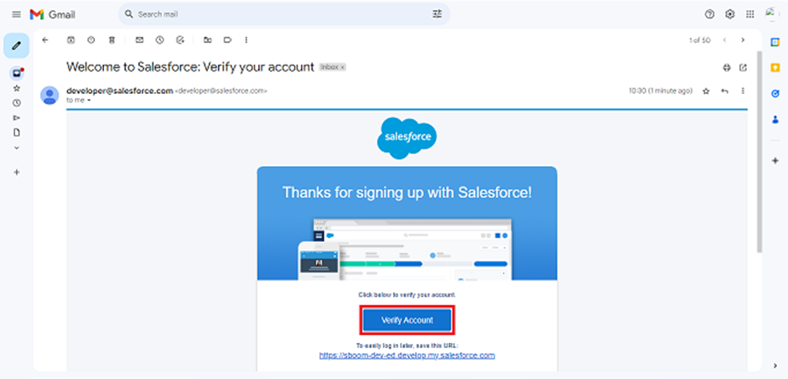**Change Password:** Click on **Change Password**.

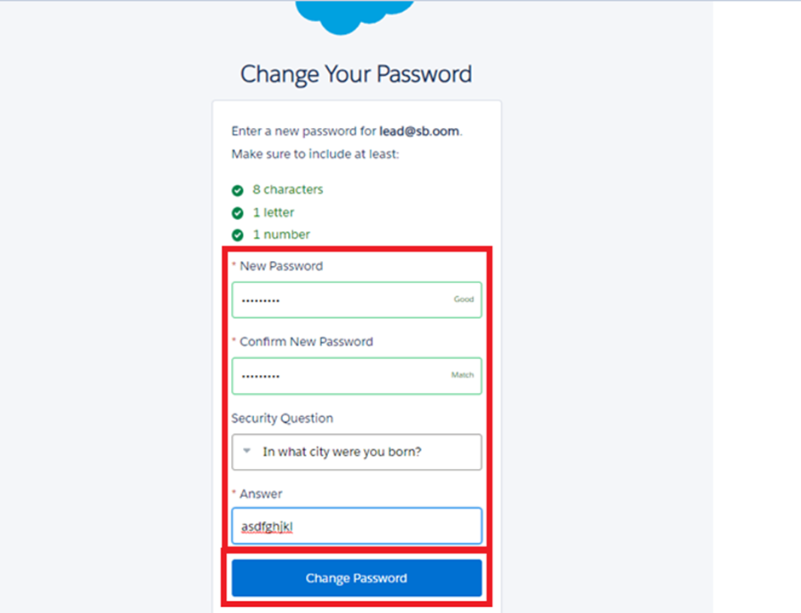

**Custom Object Creation**

In Salesforce, **Custom Objects** play a pivotal role in modeling business-specific data that cannot be adequately represented using standard objects.

**Purpose of Custom Object Creation**

The objective of creating custom objects is to:

* Capture organization-specific data such as employee records, projects, tasks, assets, services, and leave requests.
* Structure and relate data in a meaningful way that aligns with real-world operations.

**Steps to Create a Custom Object**

1. 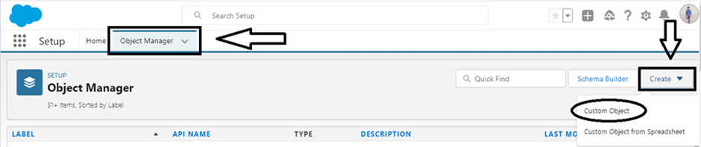**Navigate to Setup** → Object Manager → Create → Custom Object.
2. Define:
   * **Label** (e.g., “Employee”)
   * **Plural Label** (e.g., “Employees”)
   * 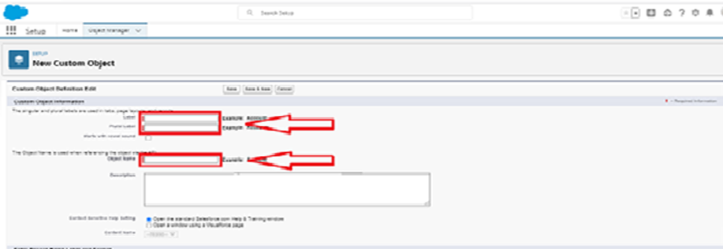**Record Name** (e.g., “Employee ID”) and data type (Auto Number/Text)
   * Display Format: EMS-{0000}, Proj-{0000}, etc.
3. Enable:
   * **Allow Reports**
   * **Allow Search**
   * **Track Field History** (if needed)
4. **Save** the object.

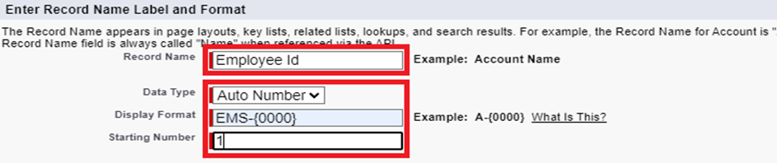

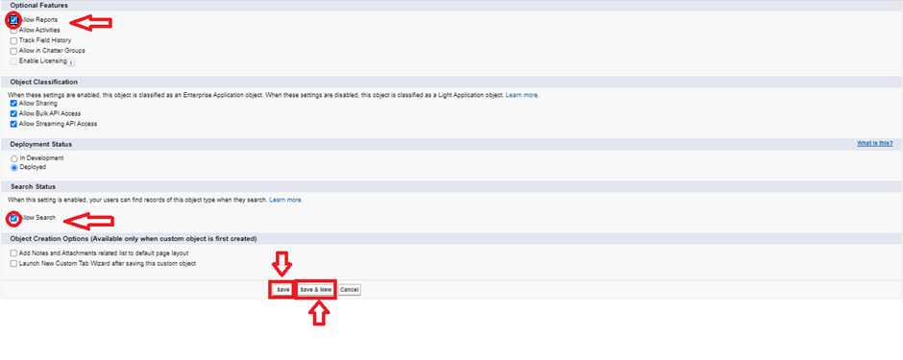

|  |
| --- |
|  |

**5.Tabs Creation**

**Steps for Tab Creation**

**1. Navigate to Tab Settings**

* Go to Setup (click on the ⚙️ gear icon).
* In the Quick Find box, type Tabs.
* Click on Tabs under the User Interface section.

**2. Create a New Custom Tab**

* Under Custom Object Tabs, click on New.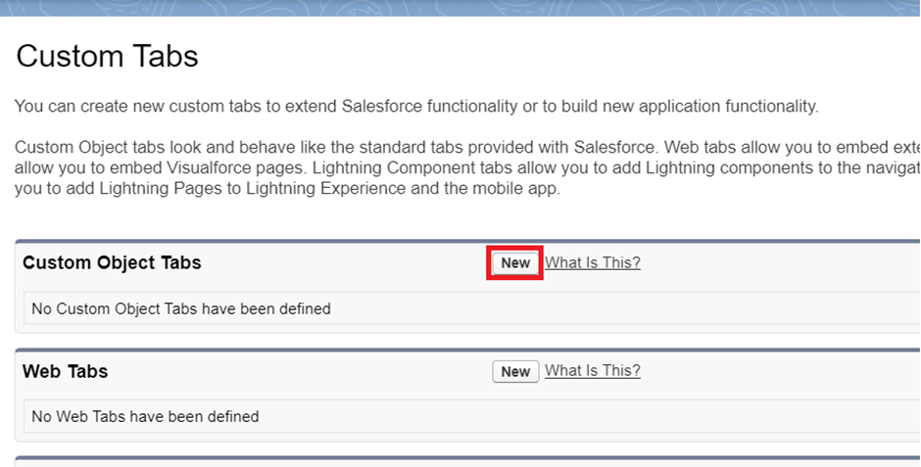

**3. Configure Tab Details**

* Select Object: Choose the object for which you want to create a tab (e.g., Employee, Project, ProjectTask, Asset, Asset Service, etc.).
* Tab Style: Choose an icon and color to represent your object tab (e.g., a briefcase for "Project").
* Tab Label: Auto-filled based on the object label.

**4. Set Tab Visibility**

* Click Next on the "Add to Profiles" page to apply the default visibility.
  + You may customize this to show/hide the tab for specific profiles (e.g., HR, Manager).
* Click Next again on the "Add to Custom Apps" page to include the tab in default apps.

**5. Save the Tab**

* 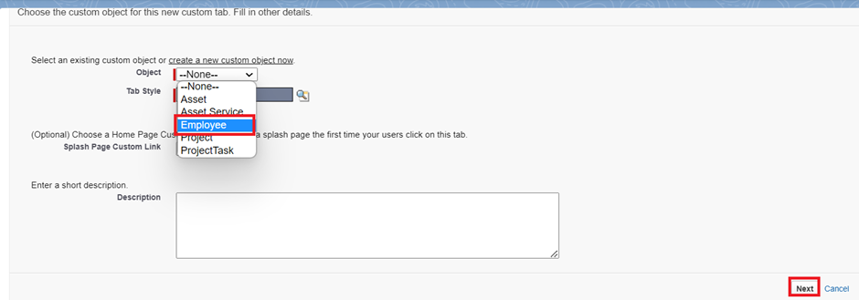Click Save to complete tab creation.

1. **Lightning App Creation**

Creating a Lightning App in Salesforce helps organize multiple custom objects, reports, dashboards, and business functions under a unified user interface

**Steps Followed to Create the Lightning App**

**1. Navigate to App Manager**

* Go to **Setup**.
* In the **Quick Find** box, type **App Manager**.
* Click on **App Manager**.
* Click the **“New Lightning App”** button.

**2. Fill App Details and Branding**

* **App Name**: Workforce Administrator Solution
* **Developer Name**: (Auto-populated)
* **Description**: *A centralized solution for managing employees, projects, tasks, and assets.*
* **Image**: (Optional – company logo or icon)
* **Primary Color (Hex)**: Default or customized as needed.

Click **Next** to proceed.

**3. App Options & Utility Items**

* Keep the default selections for app options (e.g., *App visible in Lightning Experience*).
* No utility items were added in this case.  
  Click **Next**.

**4. Add Navigation Items**

Use the search bar to find and add the following tabs to the app:

| **Navigation Items Added** |
| --- |
| Employees |
| Projects |
| Project Tasks |
| Assets |
| Asset Services |
| Leaves |
| Reports |
| Dashboards |

**5. Assign User Profiles**

* Add the app to appropriate profiles:
  + **System Administrator**
  + **Manager**
  + **HR**
  + **Remote Employee**
  + **On Site Employee**

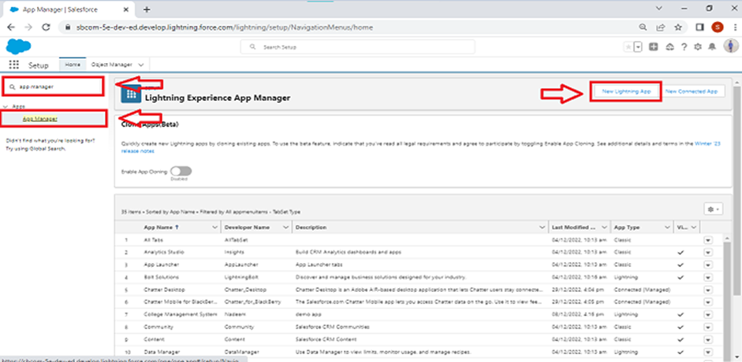Click **Save & Finish**.

**Outcome**

A fully functional Lightning App named **“Workforce Administrator Solution”** was created. It brings together all relevant tabs, enhances accessibility, and ensures a role-based interface for users.

**7. Field Creation in Objects**

**Steps to Create Fields in Objects**

1. **Navigate to Setup**  
   → Click **Object Manager**  
   → Search and select the required **custom object** (e.g., Employee)  
   → Click **Fields & Relationships**  
   → Click **New**
2. **Choose the Appropriate Field Type**  
   Select from available field types like:
   * Text
   * Number
   * Date
   * Picklist
   * Formula
   * Lookup Relationship
   * Master-Detail Relationship
   * Currency
   * Checkbox
   * Email, URL, Phone
   * Text Area / Rich / Long Text Area

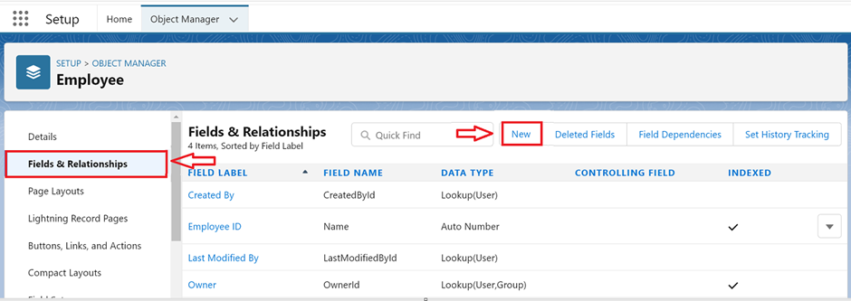

1. **Configure Field Details**
   * **Field Label** (e.g., Qualification, Project Status)
   * **Field Name** (auto-populated)
   * Additional parameters (length, decimal places, values, etc.)
   * 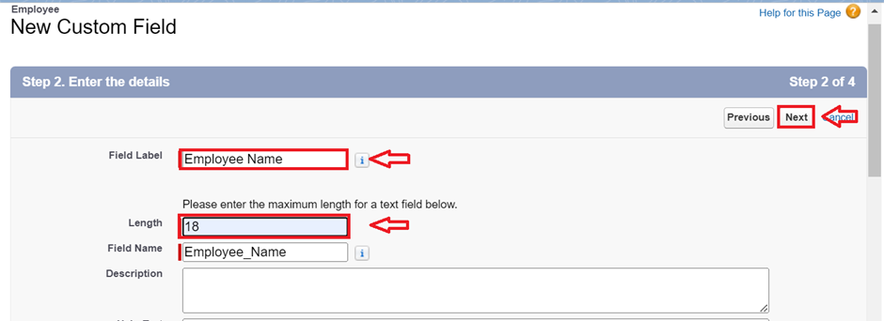**Field-Level Security** and **Page Layout Assignment**
2. **Save the Field**  
   After configuration, click **Next**, assign visibility and layout settings, and click **Save**.

**Relationships**

Salesforce objects are interconnected using relationships to enable seamless data integration, access control, and automation across modules. Below is an overview of the relationships established within the system:

1. Self-Relationship (Lookup Relationship) – Employee to Employee

* Field Name: Reports To
* Type: Lookup Relationship
* Use Case: Enables mapping of reporting hierarchies, where one employee (e.g., a team member) reports to another (e.g., a manager).
* Purpose: Tracks reporting structures within departments and projects.

2. Master-Detail Relationship – ProjectTask to Employee

* Field Name: Employee Name
* Type: Master-Detail Relationship (MDR)
* Use Case: Links tasks directly to employees.
* 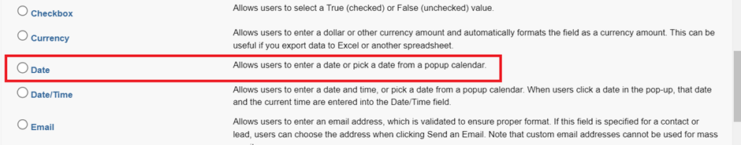Purpose: Ensures task accountability and simplifies task tracking for individual employees.

3. Master-Detail Relationship – ProjectTask to Project

* Field Name: Project Name
* Type: Master-Detail Relationship
* Use Case: Associates each task with a project.
* Purpose: Organizes tasks under specific projects for better project management and reporting.

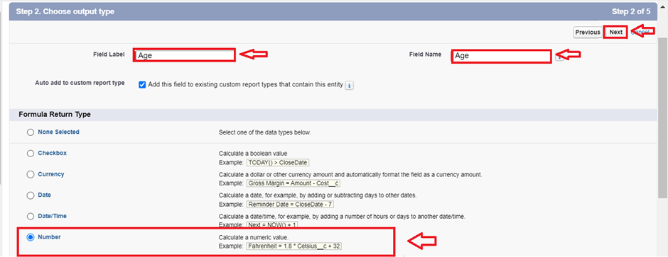

4. Lookup Relationship – Asset to Employee

* Field Name: Employee Name
* Type: Lookup Relationship
* Use Case: Connects assets to the employees they are assigned to.
* Purpose: Tracks ownership and responsibility of assets issued within the organization.

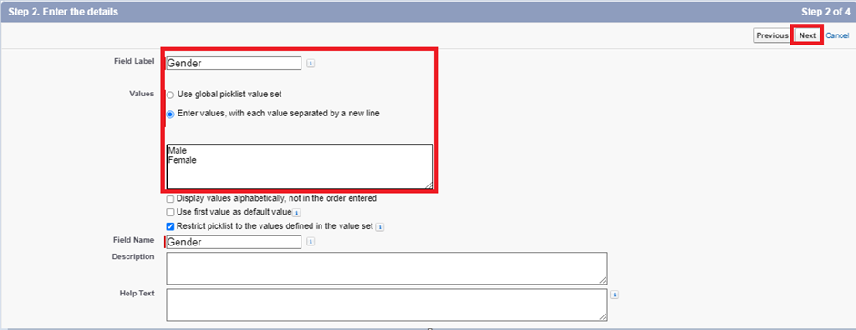

5. Lookup Relationship – Asset Service to Asset

* Field Name: Asset ID
* Type: Lookup Relationship
* Use Case: Each service request is linked to a specific asset.
* Purpose: Facilitates servicing history and maintenance tracking of organization assets.

6. Lookup Relationship – Leave to Employee

* Field Name: Employee Name
* Type: Lookup Relationship
* Use Case: Associates leave records with individual employees.
* 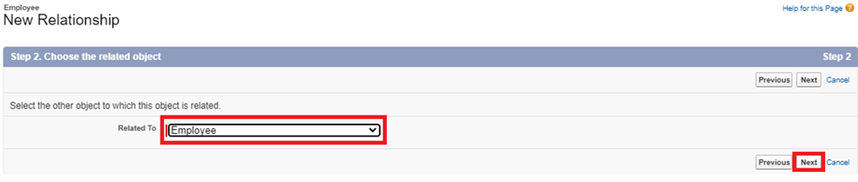Purpose: Helps HR and managers manage employee leave history, approval status, and reporting.

**Page Layouts**

Page Layouts in Salesforce are used to control the organization, visibility, and accessibility of fields, sections, and related lists on object records. For the **Workforce Administration Solution**, specific layouts are designed based on different employee roles to streamline data input and display according to the organization's needs.

**Employee Object Page Layouts**

**1. On Site Employee Layout**

* **Purpose:** Capture and display data relevant to employees working on-site, including allowances such as cab and food.
* **Sections & Fields:**

**Section: Personal Information**

* Date of Birth
* Address
* Age (Formula Field)

**Section: Allowances**

* Cab Allowance (Checkbox)
* Food Allowance (Checkbox)
* Cab Allowance Amount (Currency)
* Food Allowance Amount (Currency)

**Other Fields:**

* Employee Name (Text)
* Gender (Picklist)
* Qualification (Text)
* Experience (Text Area)
* Phone No (Phone)
* Email (Email)
* Mode of Work (Picklist: On Site, Remote)
* Login Time (Time)
* Logout Time (Time)
* LinkedIn Profile (URL)

**2. Remote Employee Layout**

* **Purpose:** Focuses on employees working remotely, with fields specific to remote work benefits.
* **Sections & Fields:**

**Section: Personal Information**

* Date of Birth
* Address
* Age (Formula Field)

**Section: Allowances**

* Wifi Allowance (Checkbox)
* Wifi Allowance Amount (Currency)

**Other Fields:**

* Employee Name (Text)
* Gender (Picklist)
* Qualification (Text)
* Experience (Text Area)
* Phone No (Phone)
* Email (Email)
* Mode of Work (Picklist: On Site, Remote)
* Login Time (Time)
* Logout Time (Time)
* LinkedIn Profile (URL)

**Page Layout Assignment by Record Type**

Record Types have been created for **On Site Employee** and **Remote Employee**, with layouts assigned as follows:

* **On Site Employee Record Type**  
  → Assigned Layout: *On Site Employee Layout*
* **Remote Employee Record Type**  
  → Assigned Layout: *Remote Employee Layout*

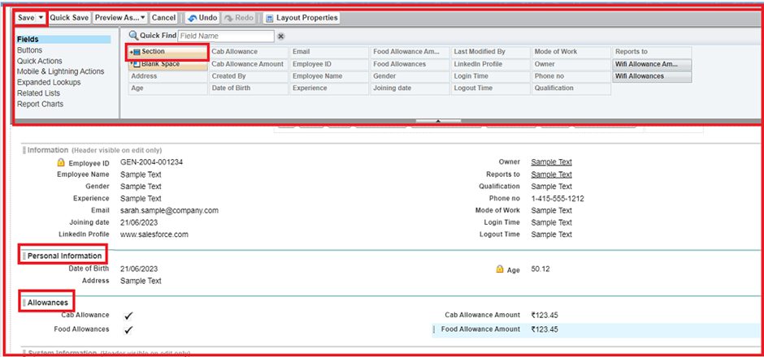

**Record Types**

Steps to Create Record Types

Activity1: Creating Record Type for On Site Employee

1. Go to Setup → Object Manager → Select Employee Object.
2. 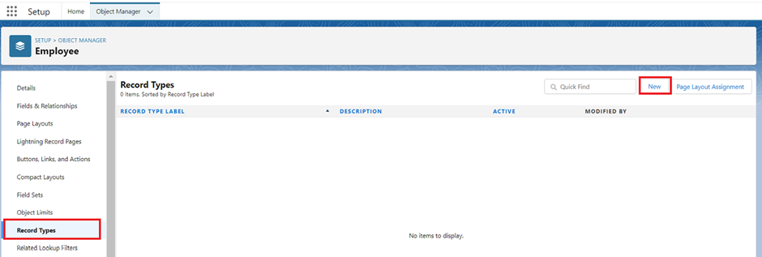Click on Record Types from the left panel → Click New.
3. Fill in the details:
   * Record Type Label: On Site Employee
   * Record Type Name: On_Site_Employee (auto-populated)
   * Make Active:
   * Enable for Profile: Manager, System Administrator → Checked

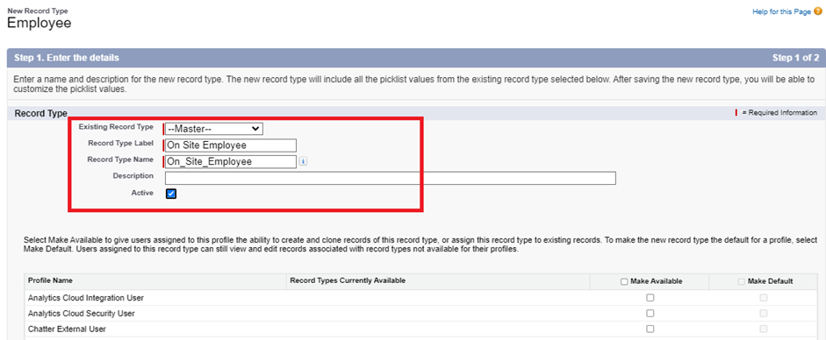

1. Under Page Layout Assignment:
   * Apply different layouts for each profile
   * Assign On Site Employee Layout for Manager and System Administrator

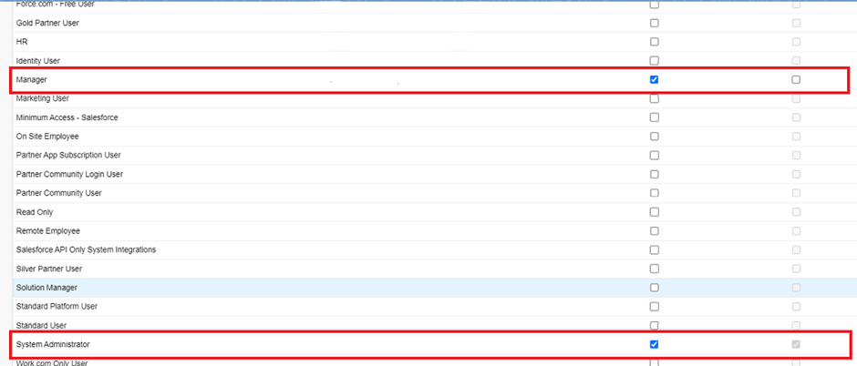

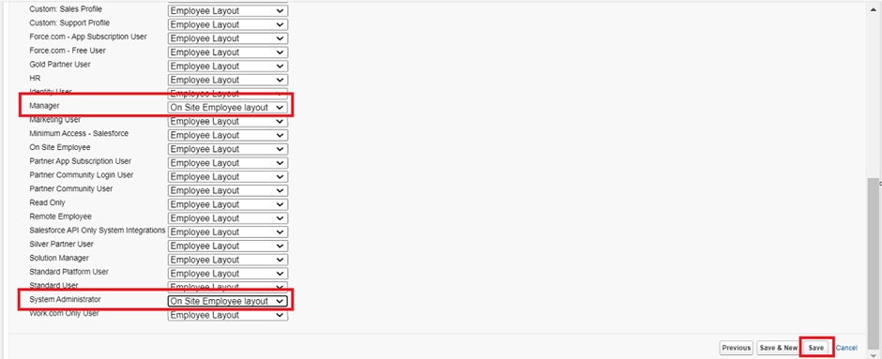

1. Click Save.

Activity 2: Creating Record Type for Remote Employee

1. Repeat the same steps as above.
2. Use the following details:
   * Record Type Label: Remote Employee
   * Record Type Name: Remote_Employee
   * Make Active: ✔️
   * Enable for Profile: Manager, System Administrator → ✅ Checked
3. Assign Remote Employee Layout to both profiles.
4. Click Save.

**Profiles & Roles**

**Custom Profiles**

**1. HR Profile**

* **Based on**: Standard User Profile (Cloned)
* **Object Access**:
  + **Read, Create, Edit, Delete** on:
    - Employee
    - Asset
    - Asset Service
* 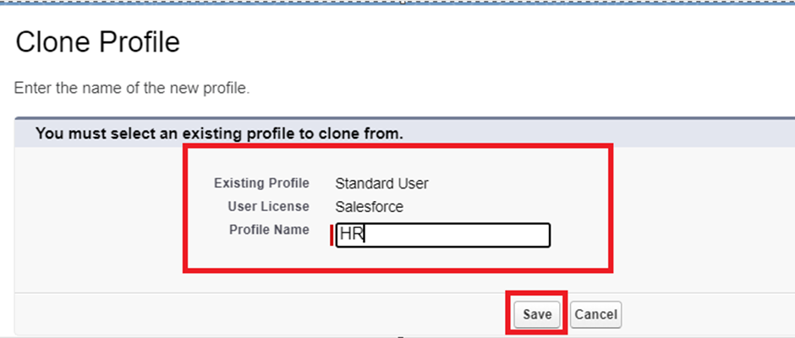**Use Case**: For HR personnel to manage employee data and asset assignments.

**2. Manager Profile**

* **Based on**: Salesforce Platform User Profile (Cloned)
* **Object Access**:
  + **Full access** on:
    - Employee
    - Project
    - Project Task
* **Use Case**: For project managers to assign and monitor project-related tasks and employee performance.

**3. On Site Employee Profile**

* **Based on**: Salesforce Platform User Profile (Cloned)
* **Object Access**:
  + **Read and Create** on:
    - Project
    - Project Task
* **Use Case**: For employees working on-site who are involved in active projects and task execution.

**4. Remote Employee Profile**

* 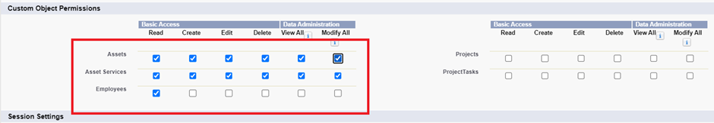**Based on**: Salesforce Platform User Profile (Cloned)
* **Object Access**:
  + **Read and Create** on:
    - Project
    - Project Task
* **Use Case**: For employees working remotely who contribute to projects from external locations.

**Role Hierarchy**

Roles define **record-level data visibility** based on hierarchy and are critical for data sharing using role-based access.

**1. HR Role**

* **Reports To**: CEO / Admin
* 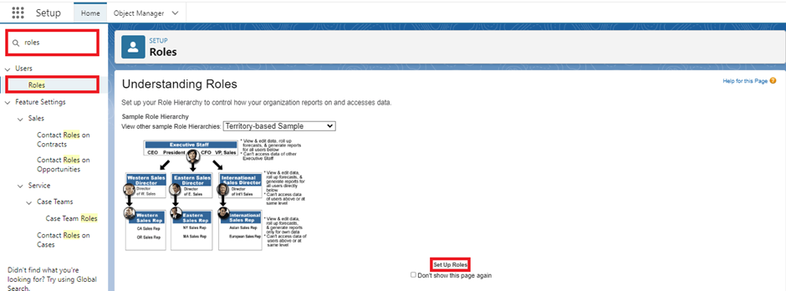**Responsibilities**: Handle employee onboarding, data entry, asset allocation, and leave management.

**2. Manager Role**

* **Reports To**: HR
* **Responsibilities**: Oversee employees, assign tasks, monitor project progress, approve leaves.

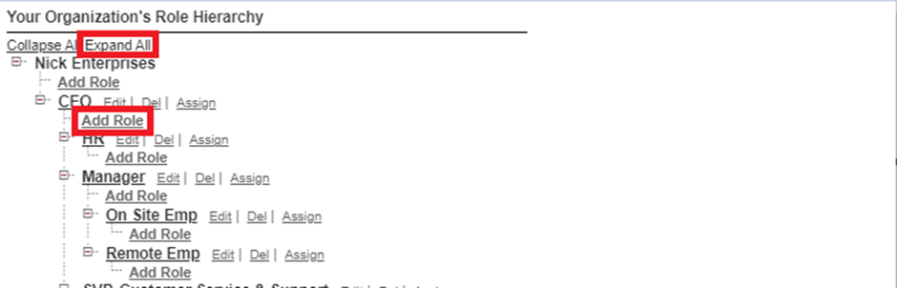

**3. On Site Employee Role**

* **Reports To**: Manager
* 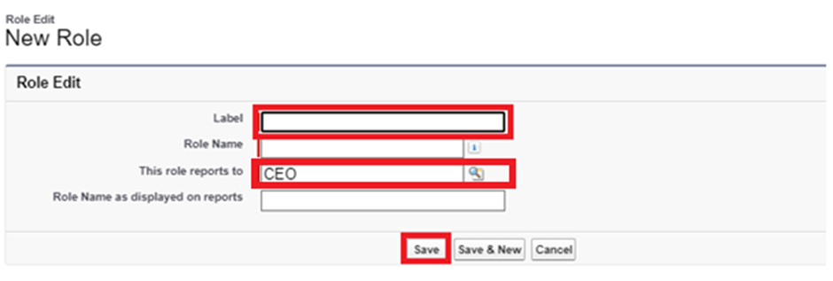**Responsibilities**: Work from physical office, handle tasks assigned on-site.

**4. Remote Employee Role**

* **Reports To**: Manager
* 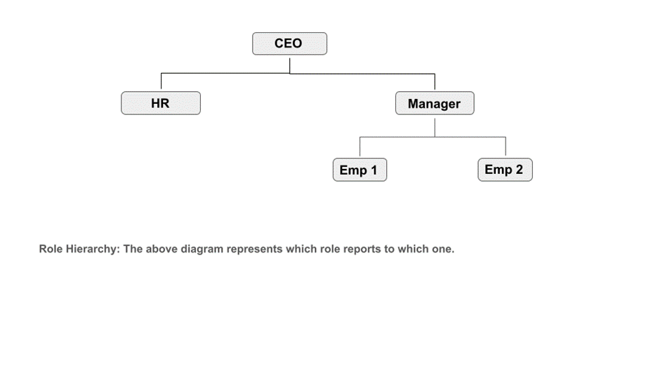**Responsibilities**: Perform work tasks remotely; update work status, log hours.

**Organization-Wide Defaults (OWD)**

The purpose of configuring **Organization-Wide Defaults (OWD)** is to define the baseline level of access to records that users do **not own**. This ensures proper **data security and privacy**, allowing only authorized users to view or modify records based on their roles or permissions.

In the **Workforce Administration Solution** for *TheSmartBridge*, OWD settings are carefully configured to enforce **restricted access** to sensitive employee, asset, and project data, while allowing collaboration where necessary.

**Configuration Steps:**

**Navigate to Sharing Settings**

1. Go to **Setup** (click on the gear icon > select **Setup**).
2. In the **Quick Find box**, type **“Sharing Settings”** and click on it.
3. 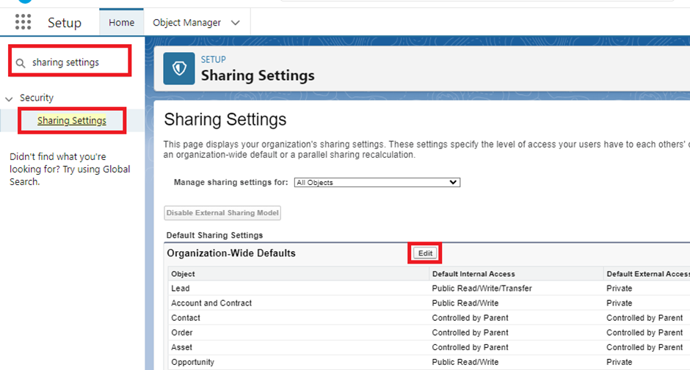On the Sharing Settings page, click **Edit** at the top of the *Organization-Wide Defaults* section.

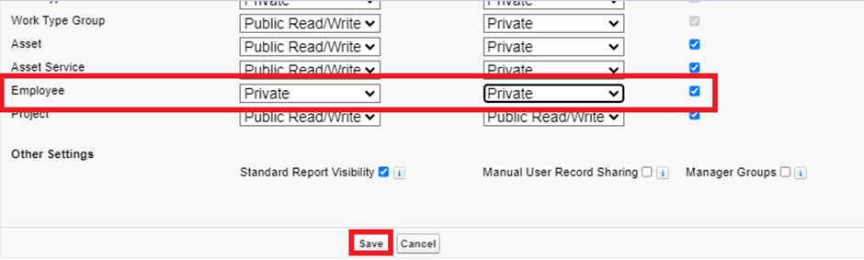

**User Management**

**Objectives of User Management**

* Assign correct roles and profiles to users
* Maintain hierarchy and access permissions
* Enforce data security through role-based visibility
* Track and manage user activity and collaboration
* 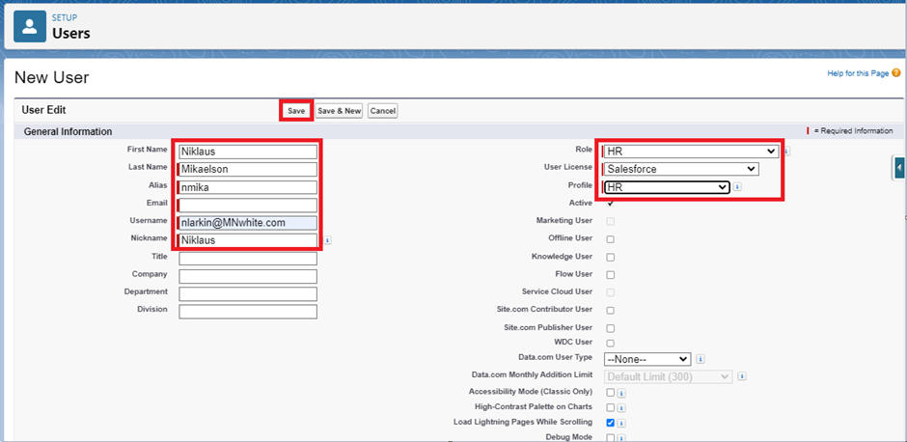Simplify user-specific UI experience with layouts and record types

**Creating Users**

To add users to your Salesforce org:

1. Navigate to: **Setup → Users → Users → New User**
2. Enter the required information:
   * **First Name** and **Last Name**
   * **Email ID** (e.g., example@gmail.com)
   * **Username** (Format: name@organization.com)
   * **Role** (e.g., HR, Manager, On Site Employee)
   * **User License** (Salesforce / Salesforce Platform)
   * **Profile** (e.g., HR, Manager, Remote Employee)
3. Click **Save**

Repeat this process to create multiple users with different roles and access levels in the org.

**Profiles**

Profiles control object-level and field-level access for users.

**Profiles Created:**

* **HR** (Clone of Standard User)
  + Access to: Employee, Asset, Asset Service
* **Manager** (Clone of Salesforce Platform User)
  + Access to: Employee, Project, Project Task
* **On Site Employee**
  + Access to: Project, Project Task
* **Remote Employee**
  + Access to: Project, Project Task

Each profile is configured by editing object permissions and setting field-level security accordingly.

**Roles**

Roles determine record-level access through the role hierarchy.

**Steps to Create a Role:**

1. Navigate to: **Setup → Roles → Set Up Roles → Add Role**
2. Enter Role Label (e.g., "Manager")
3. Assign reporting hierarchy (e.g., Manager reports to CEO)
4. Save

Repeat the steps for HR, On Site Employee, and Remote Employee roles as needed.

**User Assignments**

While creating each user, assign:

* Appropriate **Profile**
* Matching **Role**
* Valid **User License** (e.g., Salesforce Platform for limited access)

Ensure each user has proper visibility and data access as per their job responsibilities.

**Chatter Group Setup**

Internal collaboration is enhanced using Chatter Groups.

**Steps:**

1. 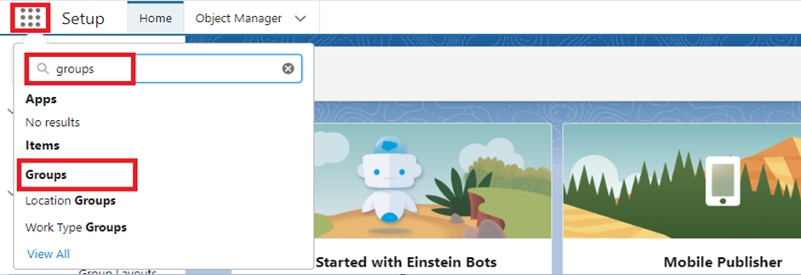Go to App Launcher → Search “Groups” → Click **New**
2. Fill group details:
   * **Group Name:** Internal Discussion
   * **Description:** Used for ongoing project collaboration
   * 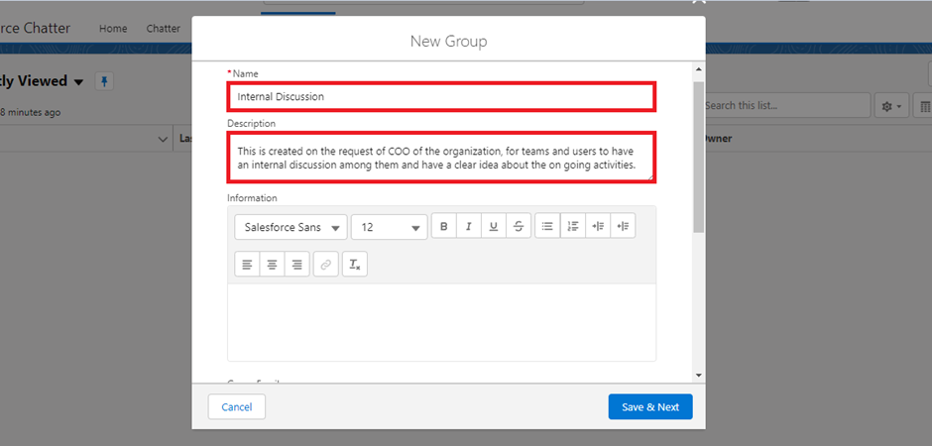**Access Type:** Private
3. Add users (e.g., HR, Manager, Employees)
4. Post a welcome message for engagement

This fosters open communication and faster decision-making.

**Record Types & Page Layouts (Role-Based UI)**

Different record types and layouts are created for tailored user experiences:

* **On Site Employee Record Type**
  + Layout: Includes all Allowance sections
* **Remote Employee Record Type**
  + Layout: Includes only WiFi Allowance section

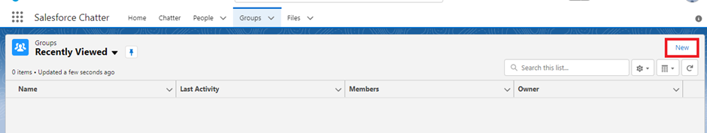

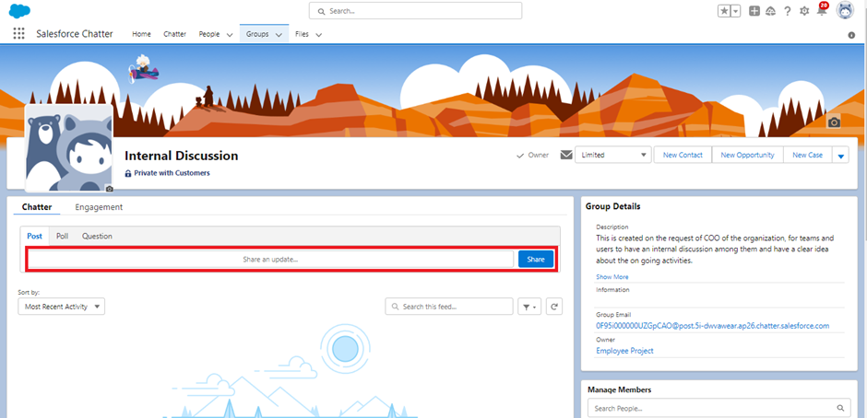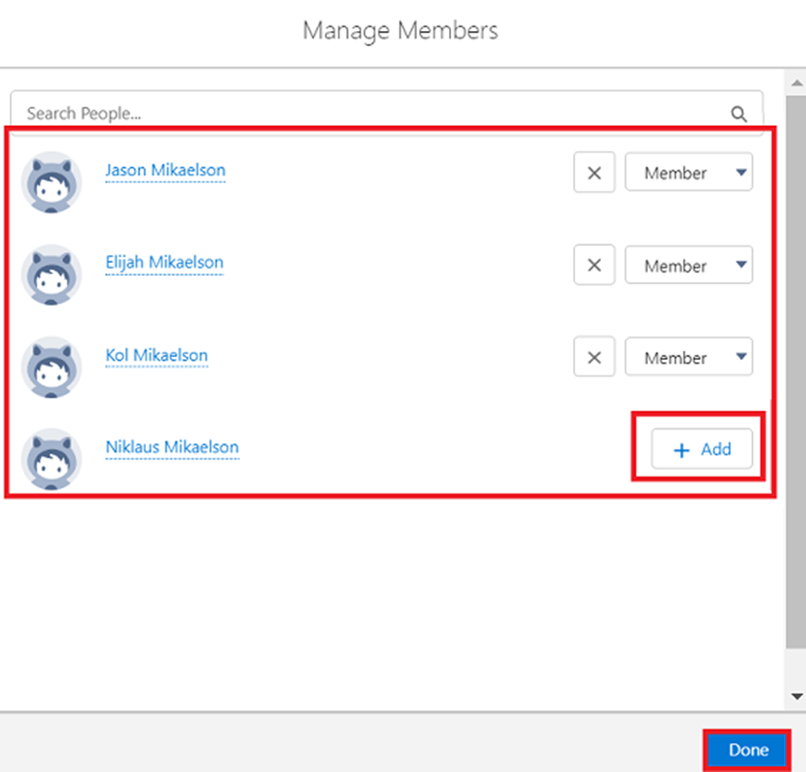

**Group Collaboration**

🔹 Objectives of Group Collaboration:

1. EncourageInternalCommunication  
   Facilitate transparent and quick communication among HRs, Managers, and Employees using Salesforce Chatter.
2. PromoteKnowledgeSharing  
   Enable team members to share files, project updates, and important announcements in a centralized group.
3. StrengthenTeamAlignment  
   Ensure all stakeholders stay informed about current tasks, employee performance, asset issues, and leave approvals.
4. IncreaseEngagement  
   Allow users to like, comment, and post within their team’s group space, improving collaboration and engagement.

Activities Performed:

Activity 1: Creating a Chatter Group

* Group Name: Internal Discussion
* Description: A private group created for employees working on projects to collaborate, ask questions, and share updates regarding ongoing activities.
* Access Type: Private (only invited users can view and contribute)
* Allow Customers: Checked (for future expansion if needed)

Steps:

1. App Launcher → Search Groups → Click New
2. Fill in required details (Group Name, Description, Access Type)
3. Skip image section → Click Next
4. Add users like HR, Manager, On Site Employee, Remote Employee to the group
5. Post a welcome message:  
   *"Welcome to the Internal Discussion Group. Here, you can post anything related to ongoing projects."*

Activity 2: Default Chatter Group Usage

* Salesforce automatically creates a default chatter group with all active users.
* This group can be used for organization-wide announcements, company policies, or system updates.

**Reports**

**Steps to Create a Report:**

**Activity 1: Creating a Basic Employee Report**

1. Go to the **App Launcher** → Search and click on **Reports**.
2. Click on **New Report**.
3. Select **Report Type**: *Employees*.
4. Click on **Start Report**.
5. Use the left panel to add required fields such as:
   * Employee Name
   * Gender
   * Mode of Work
   * Qualification
   * Joining Date
   * Email
6. Apply filters if needed (e.g., Mode of Work = "Remote").
7. Click on **Save & Run**.
8. Provide a name (e.g., *All Employees Report*) and Save.

**Activity 2: Creating a Report – Employees with Project Tasks and Projects**

1. Click on **New Report**.
2. Select Report Type: *Employees with ProjectTasks and Projects*.
3. Click on **Start Report**.
4. Drag and drop fields like:
   * Employee Name
   * Project Task
   * Project Name
   * Working Hours
   * Start Date / End Date
5. Add filters (optional).
6. Click **Save & Run**, name it *Employee Project Task Report*.

**Activity 3: Creating a Report – Employees with Assets**

1. Click on **New Report**.
2. Select Report Type: *Employees with Assets*.
3. Click on **Start Report**.
4. Add these fields:
   * Employee Name
   * Asset Type
   * Model Name
   * Date of Issue
5. Optionally filter assets by type (e.g., “Laptop”).
6. Click **Save & Run**, name it *Employee Asset Report*.

**Dashboards**

**Activity: Creating Dashboards**

**Dashboard 1: Employee Performance Overview**

**Steps to Create:**

1. Go to the App → Click on the **Dashboards** tab.
2. Click **Create New Dashboard**.

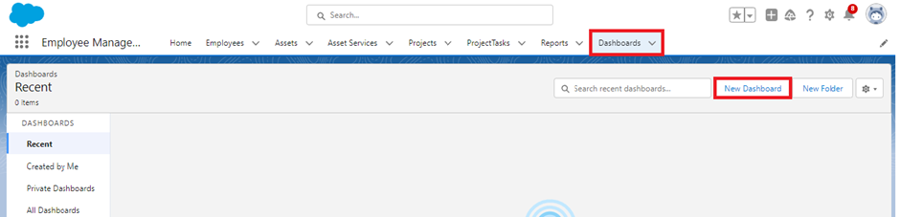

1. Enter:
   * **Dashboard Name:** Employee Performance Overview
   * **Folder:** Public Folders or a custom folder
2. Click **Create**.

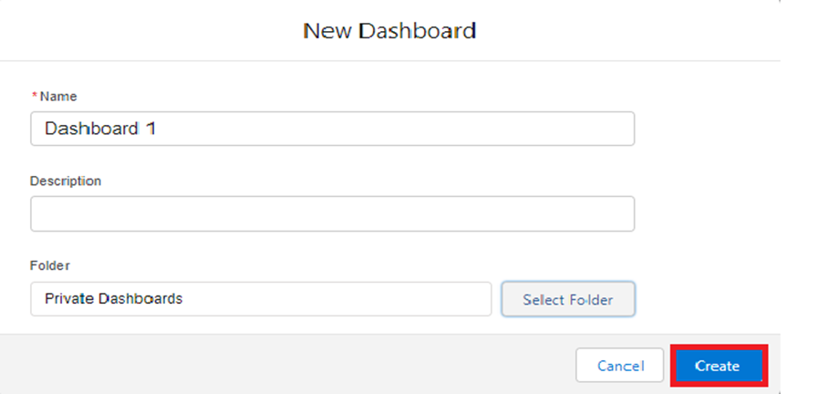

1. Click **+Component** to add visual components.
2. Choose relevant reports like:
   * **Employees with ProjectTasks and Projects**
   * **Employee Attendance (if created)**
   * 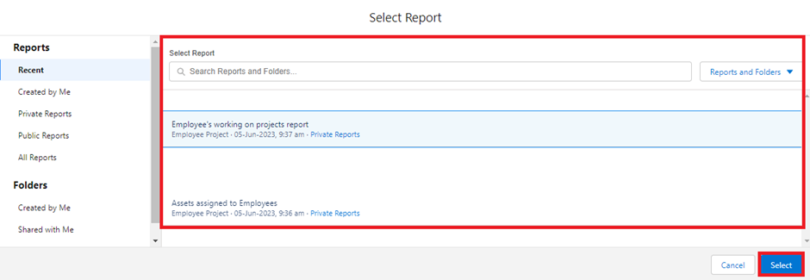**Employee Allowance Summary**
3. Select component types (bar charts, donut charts, tables) for effective visualization.
4. Click **Add**, then **Save**, then **Done**.

**Recommended Components:**

* Bar Chart: No. of Tasks per Employee
* Donut Chart: Employees by Mode of Work (On-site vs Remote)
* Table: Employees with Assigned Assets and Allowance Status

**Dashboard 2: Project Monitoring Dashboard**

**Steps to Create:**

1. Go to **Dashboards** tab → Click **Create New Dashboard**.
2. Enter:
   * **Dashboard Name:** Project Monitoring Dashboard
3. Click **+Component** and add visual components from reports like:
   * **Projects with ProjectTasks**
   * **Projects by Status**
4. Visualize key metrics using appropriate chart types.

**Recommended Components:**

* Pie Chart: Distribution of Projects by Status (Completed, Ongoing, Not Yet Started)
* Bar Chart: Projects with Highest Task Volume
* Table: Project Leads with Assigned Projects

**Dashboard 3: Asset & Service Insights**

**Steps to Create:**

1. Navigate to the **Dashboards** tab → Click **New Dashboard**.
2. Provide:
   * **Dashboard Name:** Asset & Service Insights
3. Add components based on the following reports:
   * **Employees with Assets**
   * **Asset Services by Type**
   * **Asset Usage Overview**

**Recommended Components:**

* Donut Chart: Asset Types Distribution (Laptop, CPU, etc.)
* Bar Chart: Service Requests by Type (Technical vs Non-Technical)
* Table: Employees with Issued Assets

**Approval Process**

**Steps to Create the Approval Process**

**Step 1: Navigate to Approval Process Setup**

* Go to Setup → Search for Approval Processes
* Under Manage Approval Processes For, choose Leave
* Click on Create New Approval Process → Select Use Jump Start Wizard

**Step 2: Fill in Basic Information**

* Click **Save**
* Click **View Approval Process Detail Page**

**Step 3: Initial Submission Action**

* Under **Initial Submission Actions**, click **Add New → Field Update**
* Fill in:
  + **Name**: Approval Status to Submitted
  + **Field to Update**: Status
  + **New Field Value**: Submitted
* Click **Save**

**Step 4: Approval Step – "Approval from HR"**

* Under **Approval Steps**, click **New Approval Step**
* Step Name: Approval from HR
* Click **Next**
* Under **Step Criteria**, select:
  + “Enter this step if the following criteria are met”
  + Field: Leave: No. of Days
  + Operator: equals
  + Value: 5
* Click **Next**
* Under **Assign Approver**, select:
  + Automatically assign to approver(s)
  + User with **HR Role** (e.g., Niklaus)
* Click **Save**
* Choose: **No, I’ll do this later. Take me to the approval process detail page**

**Step 5: Final Approval Action**

* Under **Final Approval Actions**, click **Add New → Field Update**
* Fill in:
  + **Name**: Approval Status to Approved
  + **Field to Update**: Status
  + **New Field Value**: Approved
* Click **Save**

**Step 6: Final Rejection Action**

* Under **Final Rejection Actions**, click **Add New → Field Update**
* Fill in:
  + **Name**: Approval Status to Rejected
  + **Field to Update**: Status
  + **New Field Value**: Rejected
* Click **Save**

**Testing the Approval Process**

1. Go to **Leave Object Tab** → Click **New**.
2. Fill in a test record with No. of Days = 5.
3. Click **Submit for Approval**.

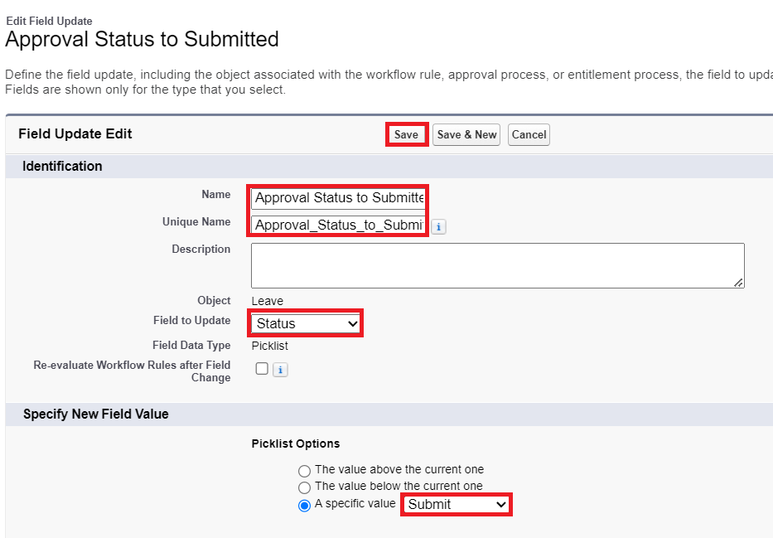

1. Verify:
   * The record moves to **Submitted** status.
   * Approval is routed to **HR Role user**.
   * Once approved, status becomes **Approved**.
   * If rejected, status changes to **Rejected**.

**Triggers and Validation**

**Apex Trigger Implementation**

Trigger: EmpInsert

Object:Employee__c  
Event:beforeinsert  
Purpose: Prevent duplicate Employee Name entries during insertion.

**Trigger Code:**

apex

CopyEdit

trigger EmpInsert on Employee__c (before insert) {

for(Employee__c pass : Trigger.New){

List<Employee__c> mynew = [

SELECT Id, Name

FROM Employee__c

WHERE Employee_Name__c =: pass.Employee_Name__c

];

if(mynew.size() > 0){

pass.Name.addError('Employee with same name is existing');

}

}

}

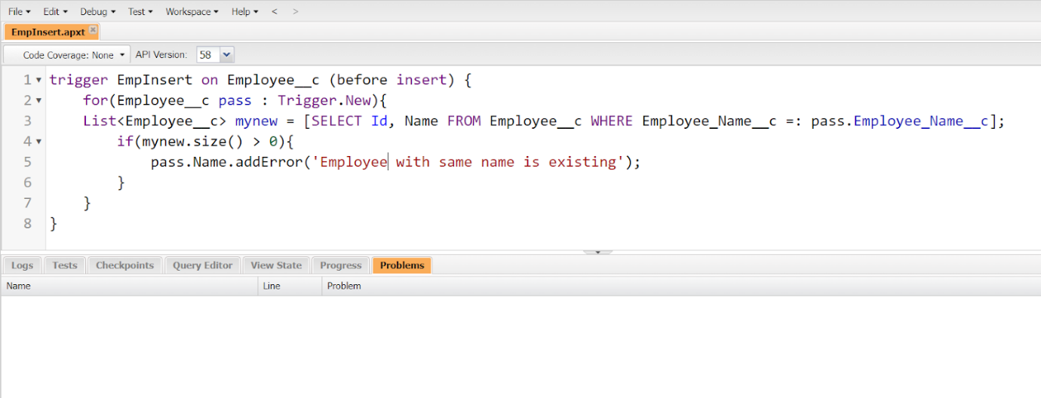

Result:

If a user attempts to create a record with an existing Employee Name, the system throws an error message:  
 *“Employee with same name is existing”*

Testing:

To test:

1. Go to Employee tab in Employee Management System App
2. Click on New
3. Enter an Employee Name that already exists (e.g., Jackie Chan)
4. Click Save

Error message will appear, blocking the insertion

**Validation Rules**

**Validation Rule 1**: Mandatory Phone Format (Employee)

Object: Employee__c  
Field: Phone__c  
Purpose: Ensure only valid 10-digit Indian phone numbers are accepted.

Formula:

plaintext

CopyEdit

NOT(REGEX(Phone__c, "^[6-9][0-9]{9}$"))

Error Message:*"Enter a valid 10-digit Indian mobile number."*

**Validation Rule 2**: Cab Allowance Amount Dependency

Object: Employee__c  
Purpose: Prevent users from entering cab allowance amount if cab allowance checkbox is not selected.

Formula:

plaintext

CopyEdit

NOT(Cab_Allowance__c)&& NOT(ISBLANK(Cab_Allowance_Amount__c))

Error Message:*"You must select 'Cab Allowance' to enter an allowance amount."*

**Validation Rule 3:** Ensure Login Time is Before Logout Time

Object: Employee__c  
Fields: Login_Time__c, Logout_Time__c

Formula:

plaintext

CopyEdit

Login_Time__c > Logout_Time__c

Error Message:*"Login time must be earlier than Logout time."*

**Validation Rule 4:** Prevent Joining Date in Future

Object: Employee__c  
Field: Joining_Date__c

Formula:

plaintext

CopyEdit

Joining_Date__c > TODAY()

Error Message: *"Joining date cannot be in the future."*

**Validation Rule 5:** Project Start and End Date Check

Object: Project__c

Formula:

plaintext

CopyEdit

Start_Date__c > End_Date__c

Error Message: *"Start date must be earlier than end date."*

**Validation Rule 6:** Leave Object - Restrict Status Change

Object:Leave__c  
Field: Status__c

Setup Instruction:

Make the Status field Read-Only during field-level security setup (Field-Level Permissions).

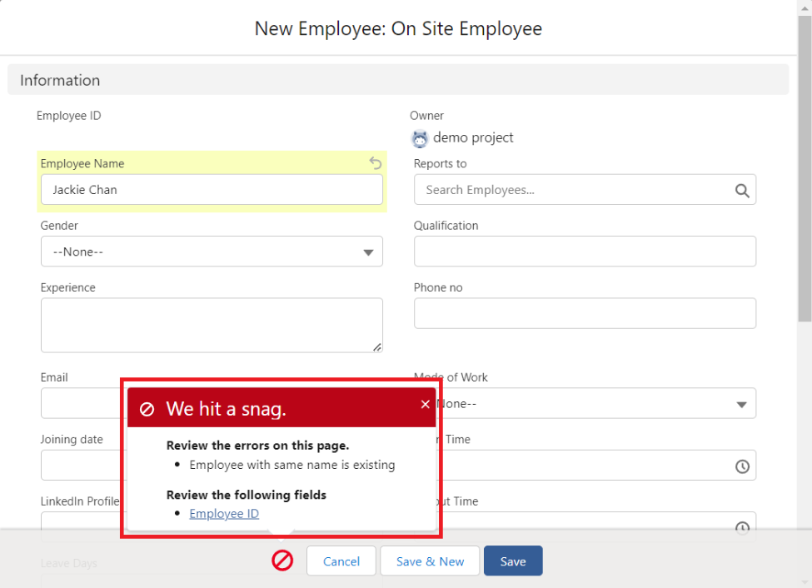

**Conclusion: Workforce Administration Solution (Dev)**

The Workforce Administration Solution project has been a comprehensive, real-time Salesforce development initiative aimed at digitalizing and streamlining employee, project, and asset management processes within TheSmartBridge organization. This solution not only centralizes crucial organizational data but also ensures efficient access control, data integrity, and business automation using Salesforce’s powerful cloud-based platform.

Throughout the development process, we explored and implemented a wide array of Salesforce features, including:

* Custom Object Creation (Employee, Project, ProjectTask, Asset, Asset Service, Leave)
* Custom Fields and Relationships (Text, Picklist, Lookup, Master-Detail, Formula)
* Profile and Role Hierarchies (HR, Manager, On-Site and Remote Employees)
* Record Types and Page Layouts for enhanced UI and user-specific data handling
* Lightning App and Custom Tabs for seamless navigation
* Reports and Dashboards for real-time business insights
* Chatter Groups to improve internal communication and collaboration
* OWD and Sharing Rules to ensure robust data security
* Approval Process Automation for leave requests
* Apex Trigger to enforce duplicate prevention logic

By completing this project, we have demonstrated proficiency in Salesforce data modeling, security implementation, automation tools, UI customization, and code-based validation — all within a real-time use case environment.

Ultimately, this solution has enabled TheSmartBridge to adopt a scalable, secure, and user-friendly platform to manage their workforce operations. The project not only fulfills organizational requirements but also lays a solid foundation for future enhancements using advanced Salesforce tools such as Flows, Process Builder, Lightning Web Components, and Einstein Analytics.

**Github link:**

1.Vallamreddy.V.S.B.Padmavati : https://github.com/padhu2005/Workforce-Administration-Solutions

2.Malisetti Sai Lakshmi Deepika : https://github.com/codeDeepu09/workforce-administration-solution-dev-